**Your name goes here**

**PSYC2300**

**Tutorial Day/Time Goes Here**

**Are you being Serial? Using mean RT to Investigate the Subitizing and Counting Discontinuation**

Numerical cognition is the study of physical quantities and symbolic numbers. Every day we evaluate small quantities to perform important tasks, such as when counting coins or when choosing the shortest coffee queue. In their seminal work, Kaufman, Lord, Reese & Volkmann (1949) measured participant response times (RT) when quantifying (enumerating), between one and eight items. Kaufman et al. found RT slope was constant or invariant when participants enumerated between one and four items. By contrast, RT slope was steep and increased linearly when participants enumerate five or more items. To explain this discontinuation in RT slope, Kaufman et al. proposed two mechanisms for the enumeration of small quantities. Subitizing, a rapid enumeration process capable of quantifying up to four items simultaneously (parallel), and Counting, a slow and accumulative (serial) enumeration process for five or more items. The current study aims to replicate the subitizing discontinuation found by Kaufman et al. and provide further evidence in favour of their two-process theory. We hypothesise participant RT slope will be invariant and shallow (fast) for the enumeration of one to four items, and that RT slope will be steep and increase linearly (slow) for the enumeration of five or more items.

**Method**

**Participants.** Twenty-nine (M=14) PSYC2300 undergraduate students completed the study.

**Stimuli and Design.** Participants completed the experiment in class on identical computers and LCD screens, with a fixed viewing distance. On a trial, participants were presented with an item set display consisting of between one and eight black discs. Each disc was 8 pixels in diameter. The experiment was self-timed and allowed participants to progress at their own rate. The experiment was an 8 (number of item sets) x 1 (number of conditions) Between-Subjects design.

**Procedure.** Participants were seated at a computer and received in-experiment instructions to count the number of discs displayed and respond with the appropriate keypad number. Each participant completed ten blocks of 80 randomised trials.

**Results**

Data analysis was only completed for correct trials. All participants were included in the analysis and performed at above 90% accuracy. Trials less than 120ms or greater than 200ms were excluded from the study. Group results for the enumeration of one to four items shows that mean RT increased at a shallow rate, ranging from 174ms (SD=30ms) to 206ms (SD=29ms; see Figure 1). Mean RT for five to eight items increased at a steeper rate and ranged between 318ms (SD=42ms) to 483ms (SD=44ms).

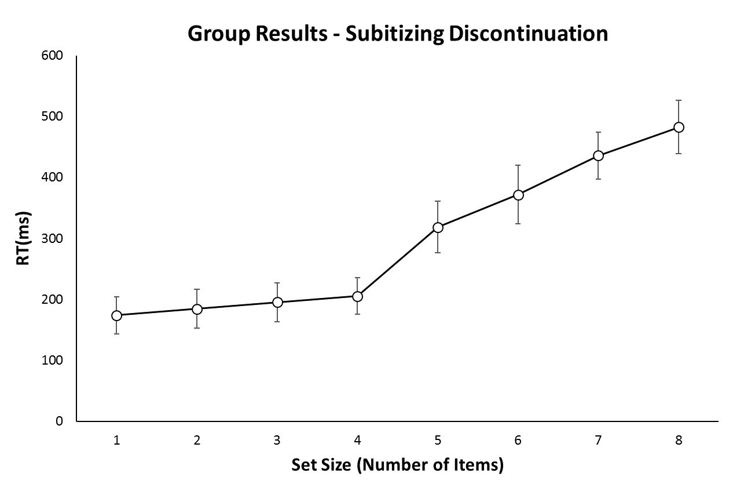

Figure 1. Graph illustrating group mean RT in milliseconds for the enumeration (or quantification) of one to eight items. The graph depicts an ‘elbow’ in RT between the processing of four and five items.

**Discussion**

Results from the current study show a clear difference in process rates between the fast enumeration of one to four items, and the slow enumeration of five to eight items. In line with our hypothesis, RT slopes were shallow for item sizes one to four, and steep for item sizes five to eight. This supports Kaufman et al.’s (1949) two-process theory for Subitizing and Counting. Our findings show a shallow increase in RT with overlapping error bars, within the range of one to four items. This supports Kaufman et al.’s hypothesis of parallel subitizing, as four or fewer items can be processed at the same rate as one item. The current study is limited by a lack of statistical inference, an issue that should be addressed in future research. In conclusion, this study has provided evidence in favour of the two process-theory of Subitizing and Counting initially proposed by Kaufman et al. Our findings are important as the ability to Subitize and Count underlie many everyday decisions and are an important aspect of Human Cognition.

­­­­**References**

Kaufman, E. L., Lord, M. W., Reese, T. W., & Volkmann, J. (1949). The discrimination of visual number. *The American Journal of Psychology, 2*(4), 27.